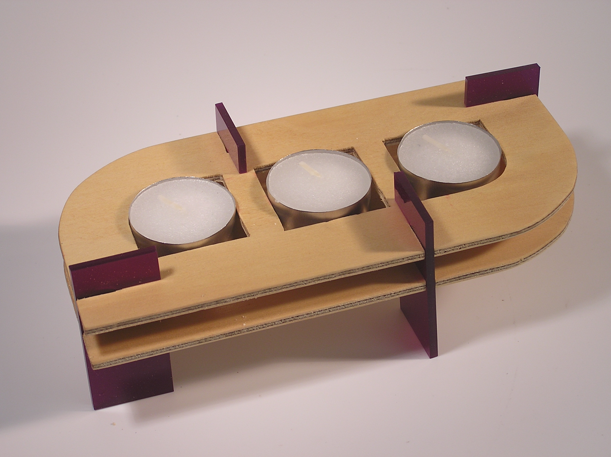

**Candle holder design project**

**Teacher notes**

The tealighter project is a simple, straightforward design project with plenty of scope for creativity and success. It is designed for Yr7-8 as a short project that could be used as a first project of the year to kick a quick goal so that students are encouraged by a quick result. Alternatively it could be used at the end of the year as something of a filler project because the time it takes to complete can be stretched or compressed as needed (which is so often the case a the year’s end)

There is minimal theory, however a design process is adhered to. A quick look at plyood, its properties and uses is appropriate in this project. There are homework and discussion questions to cover.

A good design project has tight enough design parameters to ensure success, yet offers the students an opportunity to be creative. The tealighter project has been developed with these two often competing requirements in mind. The design parameters outlined in the brief are intended to help students get success. There is usually one or two students who want to challenge these parameters and if they can present a good case, then this should be encouraged.

The making skills required for this project are minimal, however a commitment to accuracy is important especially when cutting out and filing the slots for the legs to fit into. The legs need to fit snugly and if they are too tight the acrylic is likely to crack. As mentioned in the design brief the thickness of the plywood varies and this means that some of the plywood will be a fraction too thick to accept the acrylic legs. This can be fixed y giving the offending area alight sand so that the ply is thinner where the legs slot in.

The making skills for this project are:

* accurate marking out
* cutting
* drilling with hole saw.
* Sanding

As with all design projects preparation is important. Consider having these things on hand:

* Samples of previous work. You can also visit [www.designability.com.au/projects/tealighter/gallery](http://www.designability.com.au/projects/tealighter/gallery) to see more
* All the tools and equipment at the ready
* Enough ply pieces and legs and some spares for breakages

The teacher demonstration of the making process is a helpful way for students not only to gain skills, but to help inform their design decisions. Students should take notes during or shortly after the demonstration. The *working with plywood* sheet has been provided for this purpose.

Tools required:

* Coping saw
* Reciprocating saw
* Drill press with 38mm hole saw
* Sanding paper
* Needle file (flat)

Parts supplied by Designability Group Pty Ltd:

* Ply wood cut to size (two per student)
* Acrylic legs (four per student)
* Tea light candles (3 per student)

The student notes are provided in a folio format with contents page. This is to make it easy to submit a completed folio. This kind of hand-holding can be valuable to model the requirements of more senior work without being onerous.

Once the project is finished it is always a good idea to take some good photos of the best work to serve as an inspiration for future years.

Suggested teaching programme:

|  |  |  |  |  |
| --- | --- | --- | --- | --- |
| Lesson | Content | Delivery | Page | Tasks |
| 1 | Introduction | Show examples of previous work.  Discuss design brief very briefly.  Explain the steps of the design process.  Explain the marking scheme |  | Read pages |
| 2 | Plywood | Read through information sheet on plywood.  Show samples of different plywoods.  Discuss discussion points. |  | Complete list of other manf. boards |
| 3 | Working with plywood | Demonstration of marking out, cutting, drilling and finishing |  | Students complete the worksheet in point form |
| 4 | Design brief | Explanation of design brief in detail  Read through brief explaining all details. |  | Students are encouraged to ask questions |
| 5 | Design concepts | Demonstration of concept sketching – alternatively show section on concept sketching from video: ‘Graphics Booster’ (Designability)  Read through tips for concept sketching |  | Students commence concept sketching.  Give feedback throughout this stage. |
| 6 | Concepts and development | Review student deisigns and give feedback. Look for designs that would be too difficult to make or slots too close to edges that would make weak parts of plywood that are likely to break off.  Show how to use a graphics or CAD program to generate an accurate top view of a tealighter example |  | Students revise their own work and decide on a final desing.  This design is then developed as an accurate top view in a graphics or CAD program. Print it out scale 1:1 |
| 7 | Marking out | Use a print out of the top view as a marking out plan. |  | Students mark out their design showing outline, slots and crosses for locations of centres of holes. |
| 8 | Making | Facilitate making.  Supervision. |  | Cut out overall shapes  Drill holes using 38mm hole saw. |
| 9 | Making | Facilitate making.  Supervision. |  | Cut slots.  Shape slots using needle files |
| 10 | Making | Facilitate making.  Supervision.  Hand out tea lights |  | Check slot sizes with legs and modify if necessary.  Finish off pieces by sanding and polishing. |
| 11 | Completion | Feedback from teacher |  | Complete evaluation |
| 12 | Submission | Explain how to format the folio |  | Complete and hand in folio |



Candle holder design project

**Folio by:**

**Class: Teacher:**

**Contents**

Introduction

Portfolio task list and marks

Information sheets

Working with plywood

Design brief

Concept sketching

Evaluation

Portfolio task 1

Introduction

In this project you will design a desktop candle holder using plywood and a simple construction technique. There is a wide range of creative possibility and so as a designer you are expected to make the most of this.

Students learn about:

* Plywood, its properties and applications
* Accuracy
* The design process and working to a brief

Students learn to:

* Generate concept sketches using quick techniques
* Evaluate designs
* Generate computer representations of chosen design.
* Use a range of simple hand tools and equipment
* Design a product according to a set of parameters.

Portfolio task list and marks

|  |  |  |  |
| --- | --- | --- | --- |
|  | **Description** | **Mark** | **Max** |
| 1 | Find and present pictures of three objects made out of plywood that exhibit outstanding creativity. Label the object and provide the name of the designer and the year it was designed. Briefly explain what makes each of these innovative. |  | 15 |
| 2 | Concept sketches |  | 15 |
| 3 | Computer generated top view of chosen design |  | 10 |
| 4 | Quality of construction |  | 10 |
| 5 | Originality and creativity of design |  | 40 |
| 6 | Complete the general evaluation questions. |  | 10 |
|  | **Total** |  | **100** |

Information sheets

**Plywood**

Plywood is a *manufactured* board. That is, the wood is not simply straight off the tree. It is cut into thin layers called veneers and then glued back together in a different way. Plywood has several layers and each of these layers has the grain going in a different direction. This gives the material extra strength, and in some cases can even make it waterproof. The outer veneers are usually made from nicer timber unless no one is going to see them.

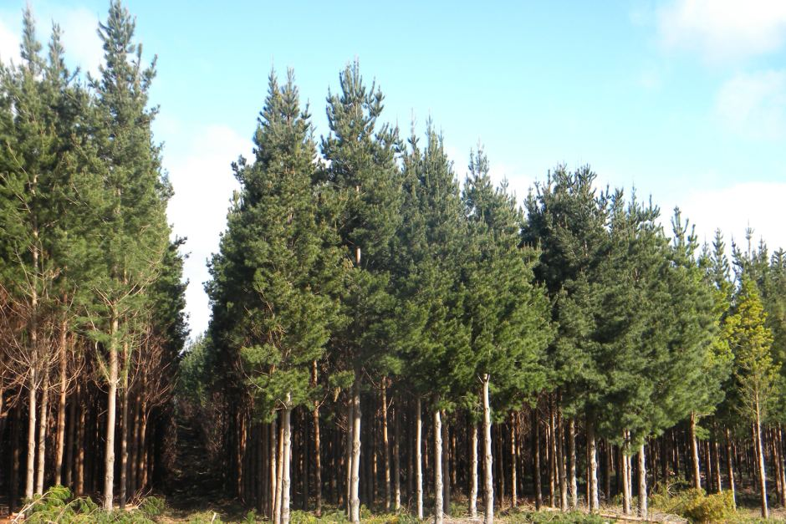

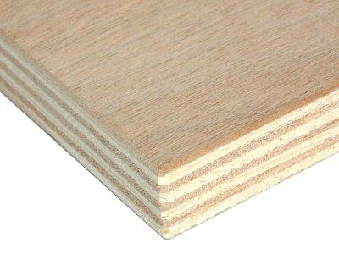

One advantage of using manufactured boards is that the physical properties of the board are consistent and you can make a very large sheet size. 2400mm x 1200mm is a fairly standard sheet size for manufactured boards. To find a sheet of timber this size would need a very big tree, probably the kind of tree that should not be cut down.

Manufactured boards are often made from plantation timber such as radiate pine. These trees take approximately 15 years to reach maturity and are then harvested, just like farmers harvest a crop, but it just takes longer to grow. This is so much better than cutting down old growth forests that can take a hundred years to grow back.

Plywood is a very versatile material for designers and it has caught the attention of creative people.

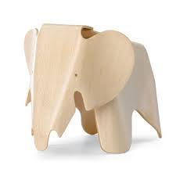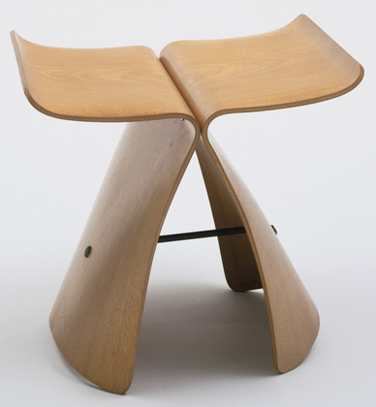

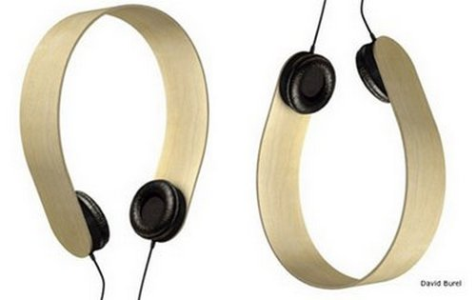

Stool by Arata Isozaki Elephant by Charles Eames Headphones by D Burela

List three other kinds of manufactured boards: Chipboard, particle board, MDF, masonite

Discussion: How do they bend plywood? Plywood is bent prior to the veneers being glued together. This involves steaming, gluing and pressing the ply in a form while it dries.

**Working with plywood**

|  |  |  |  |
| --- | --- | --- | --- |
| **Step** | **Equipment used** | **Safety** | **Technique** |
| **Marking out** | **Pencil**  **Rule**  **Marking out plan** | **N/A** | **Use marking out plan to mark out shape to cut on piece of plywood.**  **Be as accuarate as possible.**  **Mark out hole centres with a cross (no need to mark out the whole circle)** |
| **Cutting and shaping** | **Coping saw**  **Reciprocating saw**  **Needle file** | **Hold work well in vise or clamp**  **Keep fingers away from moving parts.**  **Keep blade tight.**  **Lower foot on machine.**  **Safety Glasses** | **Cut on the waste side of the line.**  **Push work into moving blade.**  **Use two hands.**  **Keep checking how much you have filed off.** |
| **Drilling** | **Pedestal drill**  **Hole saw** | **Safety glasses**  **Exclusion zones**  **Keep hands away from moving parts.**  **Remove chuck key (keyless chuck is recommended)**  **Clamp work properly (table height may need changing)** | **Clamp work in place**  **Test to see if drill is in correct place.**  **Turn on drill and lower it into the piece.**  **If you drill too quickly the ply may tear and splinter.** |
| **Finishing** | **Sanding paper**  **Beeswax furniture polish**  **Rag** | **Dust mask** | **Lightly sand down any rough edges**  **Apply beeswax and polish it off.** |

Design Brief

Tea light candles are small, single use candles that offer designers a range of creative possibilities for use around the home. This project requires you to design a holder for three tealight candles. You will be given two pieces of plywood. The top piece will have a hole for each candle and the bottom piece simply supports it. The two pieces of plywood are held together by the legs which will be supplied.

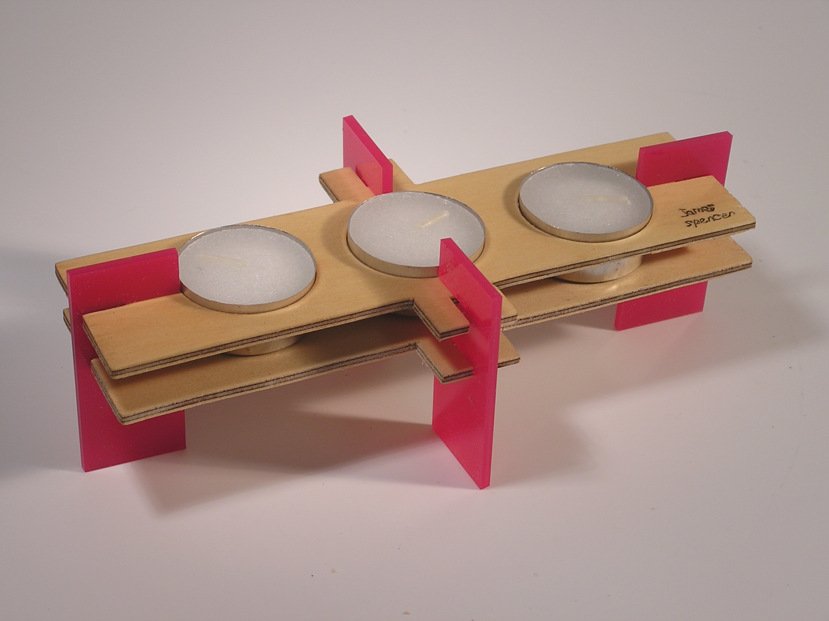

You will be given:

* Four standard legs
* 3 tea light candles
* 2 pieces of ply 90 x 200mm 3mm thick

Design parameters:

* Your tealighter must hold three candles and use four legs
* The three tea light candles can go anywhere
* Outline of lower piece should be the same as the top piece
* Location of legs is up to you, but the piece must be stable
* The finish on the ply will be beeswax furniture polish.
* The pieces of ply will need slots to accept the legs. The slots are 15mm x 3mm wide.

Design process

1. Complete a page of concept sketches
2. Develop your chosen design by completing a top view on computer
3. Print this out and use it as a marking out plan
4. Transfer the design to the plywood
5. Cut, drill, shape and finish the plywood to make your tealighter

Tips when making

* Ensure that you mark out accurately
* Cut as close as you can to the marking out line without going over it
* Use the needle file to create the correct dimensions for each of the slots
* If the legs are difficult to push in then your piece of ply may happen to be slightly thick. Sand the area on the ply that needs to fit under the slots of the legs.
* Don’t make any part of the plywood too narrow or it will break.

The most basic version of this product is shown here. It is up to you to use your design flair to make it a whole lot more interesting. Be clever.

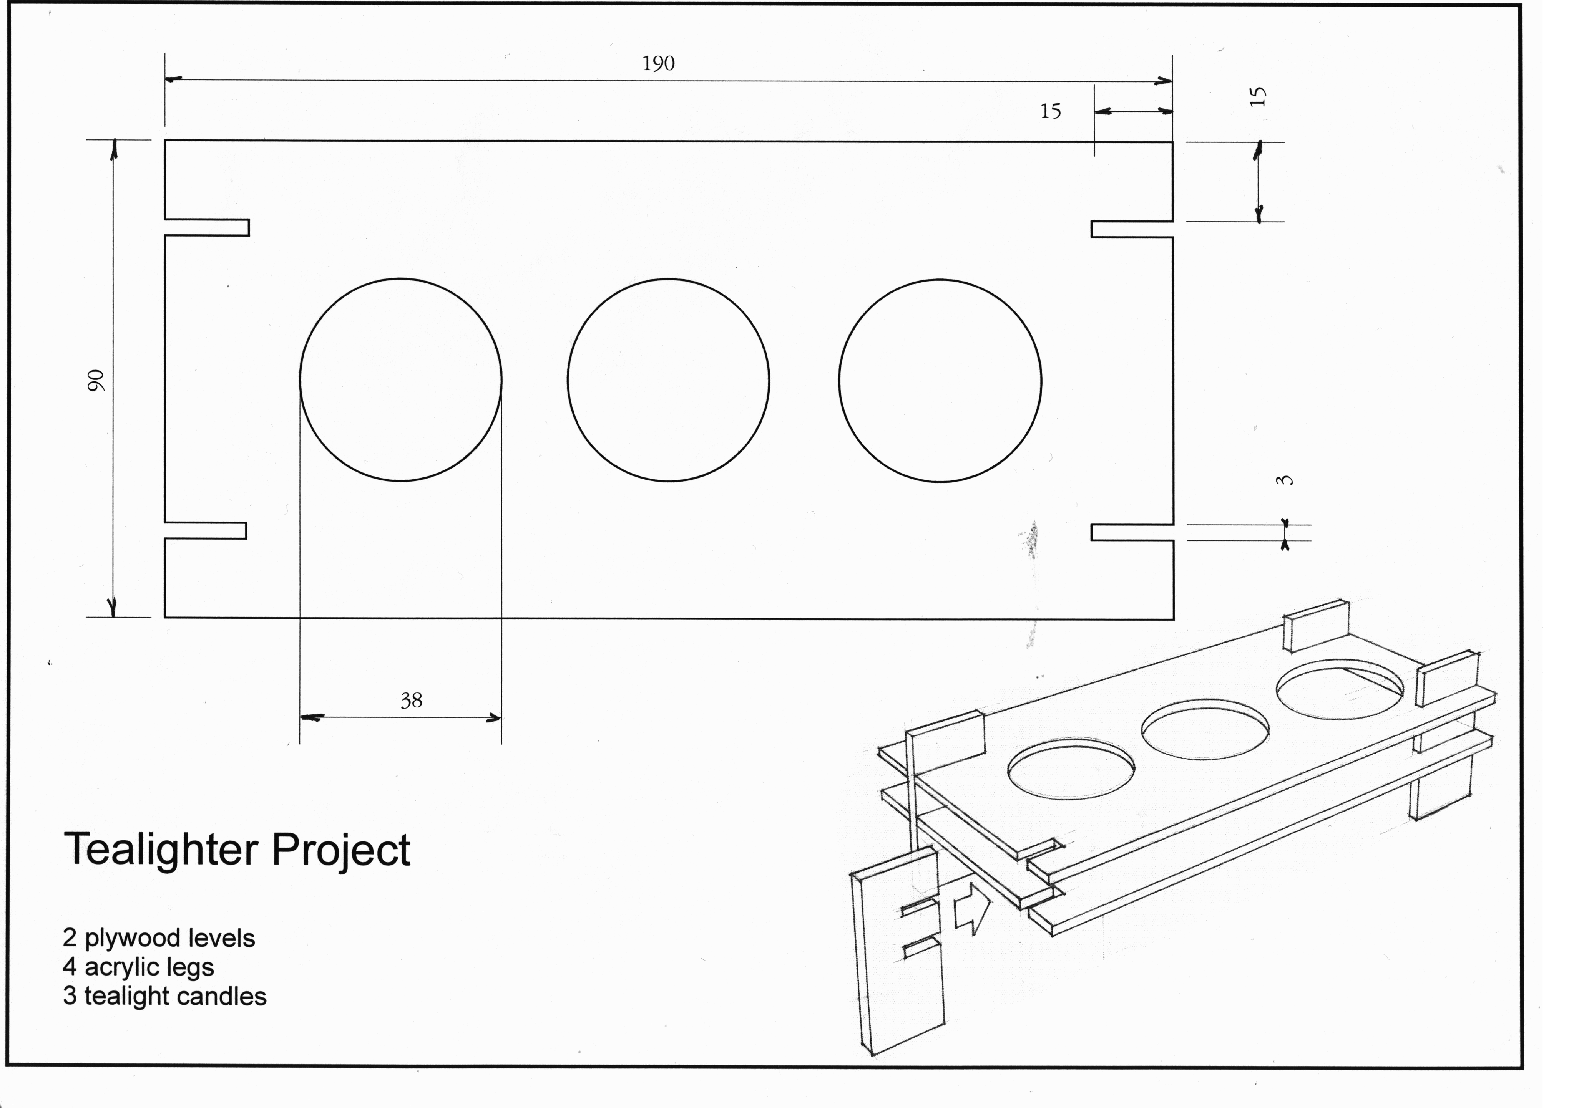

**Design Concepts**

Draw some freehand concepts using fine-liner only. Show top views and side views and try a 3D view. Label the parts. Explore a range of ideas. Example:

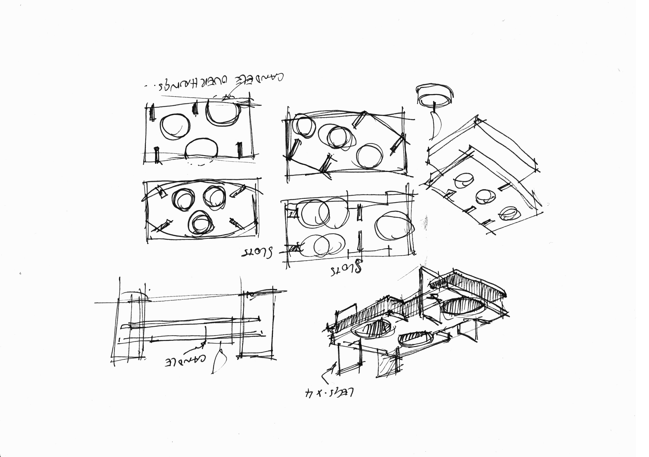

Here are some tips to remember when doing concept sketching:

* Have something that inspires you. Draw quickly. You will have more ideas if you are in a ‘drawing quickly’ frame of mind.
* Don’t be concerned about mistakes (in fact all the lines are probably ‘wrong’ so you just have to get over it and keep drawing)
* Use fineliner only. This way you can’t rub out mistakes.
* Draw lightly to begin with. These are called construction lines and will give you some idea of shapes.
* Go over the construction lines that define the shape you want. Making them darker will take your eye away from the other construction lines.
* Do some quick shading with quick diagonal lines called hatching. Make sure they are fast and light.
* Include some annotation to explain your ideas.
* If your shapes become difficult to ‘read’ then some contour lines (as above) will help define the shape you are drawing.

Fill this page with quick sketches of your ideas.

**Evaluation**

Answer the following questions.

1. What did you learn about working with plywood?
2. What changes did you make to your design during the making process?
3. Why did you make these changes?
4. If you were to make another tealighter, how would it be different to the one you have made?