

Candle holder design project

**Folio by:**

**Class: Teacher:**

**Contents**

Introduction 2

Portfolio task list and marks 2

Information sheets 3

Working with plywood 4

Design brief 5

Concept sketching 7

Evaluation 9

Portfolio task 1 10

Introduction

In this project you will design a desktop candle holder using plywood and a simple construction technique. There is a wide range of creative possibility and so as a designer you are expected to make the most of this.

Students learn about:

* Plywood, its properties and applications
* Accuracy
* The design process and working to a brief

Students learn to:

* Generate concept sketches using quick techniques
* Evaluate designs
* Generate computer representations of chosen design.
* Use a range of simple hand tools and equipment
* Design a product according to a set of parameters.

Portfolio task list and marks

|  |  |  |  |
| --- | --- | --- | --- |
|  | **Description** | **Mark** | **Max** |
| 1 | Find and present pictures of three objects made out of plywood that exhibit outstanding creativity. Label the object and provide the name of the designer and the year it was designed. Briefly explain what makes each of these innovative. |  | 15 |
| 2 | Concept sketches |  | 15 |
| 3 | Computer generated top view of chosen design |  | 10 |
| 4 | Quality of construction |  | 10 |
| 5 | Originality and creativity of design |  | 40 |
| 6 | Complete the general evaluation questions. |  | 10 |
|  | **Total** |  | **100** |

Information sheets

**Plywood**

Plywood is a *manufactured* board. That is, the wood is not simply straight off the tree. It is cut into thin layers called veneers and then glued back together in a different way. Plywood has several layers and each of these layers has the grain going in a different direction. This gives the material extra strength, and in some cases can even make it waterproof. The outer veneers are usually made from nicer timber unless no one is going to see them.

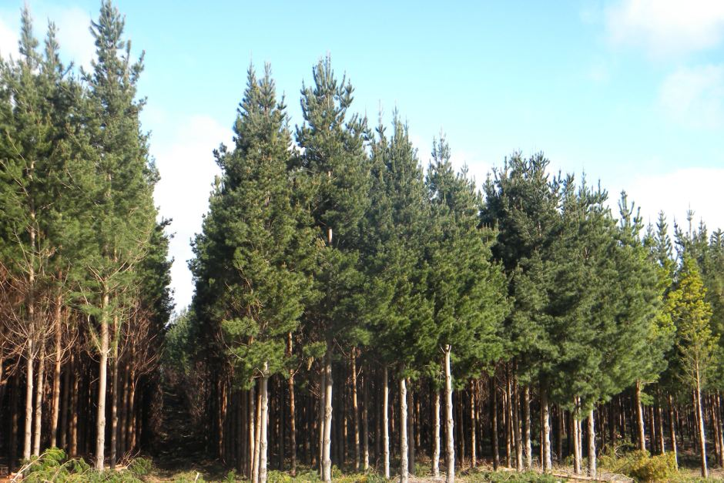

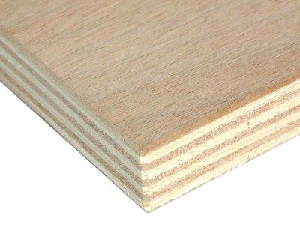

One advantage of using manufactured boards is that the physical properties of the board are consistent and you can make a very large sheet size. 2400mm x 1200mm is a fairly standard sheet size for manufactured boards. To find a sheet of timber this size would need a very big tree, probably the kind of tree that should not be cut down.

Manufactured boards are often made from plantation timber such as radiate pine. These trees take approximately 15 years to reach maturity and are then harvested, just like farmers harvest a crop, but it just takes longer to grow. This is so much better than cutting down old growth forests that can take a hundred years to grow back.

Plywood is a very versatile material for designers and it has caught the attention of creative people.

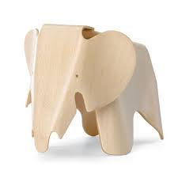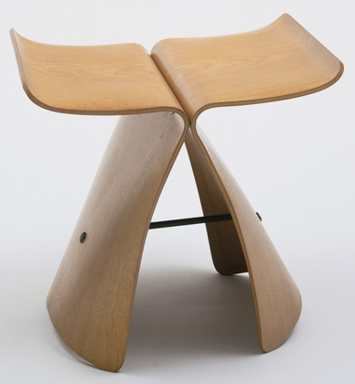

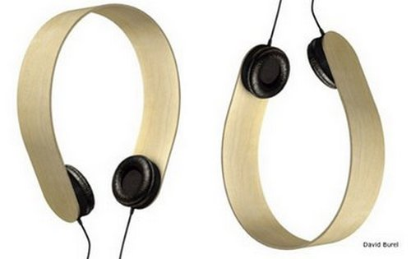

Stool by Arata Isozaki Elephant by Charles Eames Headphones by D Burela

List three other kinds of manufactured boards:

Discussion: How do they bend plywood?

**Working with plywood**

|  |  |  |  |
| --- | --- | --- | --- |
| **Step** | **Equipment used** | **Safety** | **Technique** |
| **Marking out** |  |  |  |
| **Cutting and shaping** |  |  |  |
| **Drilling** |  |  |  |
| **Finishing** |  |  |  |

Design Brief

Tea light candles are small, single use candles that offer designers a range of creative possibilities for use around the home. This project requires you to design a holder for three tealight candles. You will be given two pieces of plywood. The top piece will have a hole for each candle and the bottom piece simply supports it. The two pieces of plywood are held together by the legs which will be supplied.

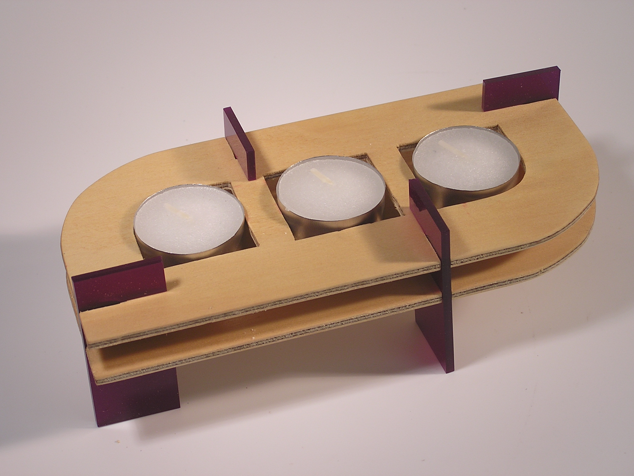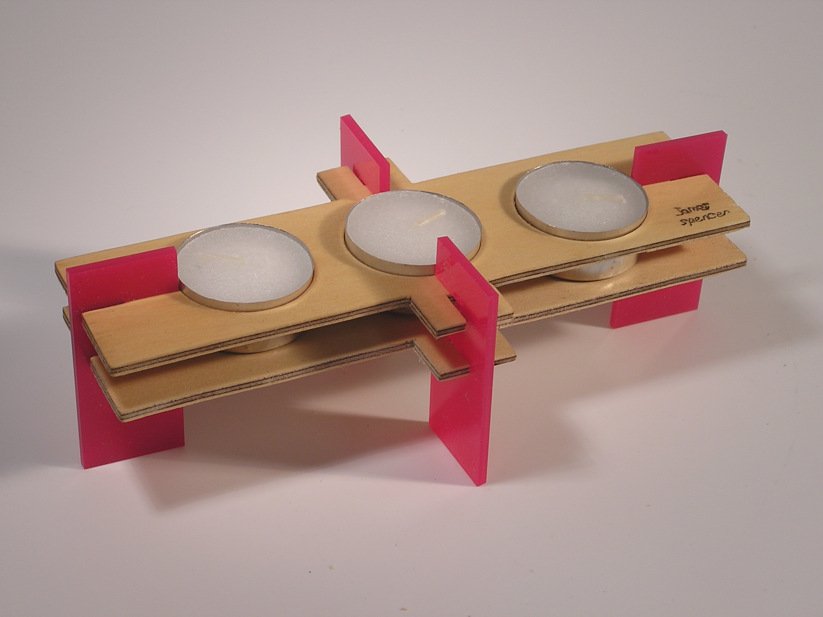

You will be given:

* Four standard legs
* 3 tea light candles
* 2 pieces of ply 90 x 200mm 3mm thick

Design parameters:

* Your tealighter must hold three candles and use four legs
* The three tea light candles can go anywhere
* Outline of lower piece should be the same as the top piece
* Location of legs is up to you, but the piece must be stable
* The finish on the ply will be beeswax furniture polish.
* The pieces of ply will need slots to accept the legs. The slots are 15mm x 3mm wide.

Design process

1. Complete a page of concept sketches
2. Develop your chosen design by completing a top view on computer
3. Print this out and use it as a marking out plan
4. Transfer the design to the plywood
5. Cut, drill, shape and finish the plywood to make your tealighter

Tips when making

* Ensure that you mark out accurately
* Cut as close as you can to the marking out line without going over it
* Use the needle file to create the correct dimensions for each of the slots
* If the legs are difficult to push in then your piece of ply may happen to be slightly thick. Sand the area on the ply that needs to fit under the slots of the legs.
* Don’t make any part of the plywood too narrow or it will break.

The most basic version of this product is shown here. It is up to you to use your design flair to make it a whole lot more interesting. Be clever.

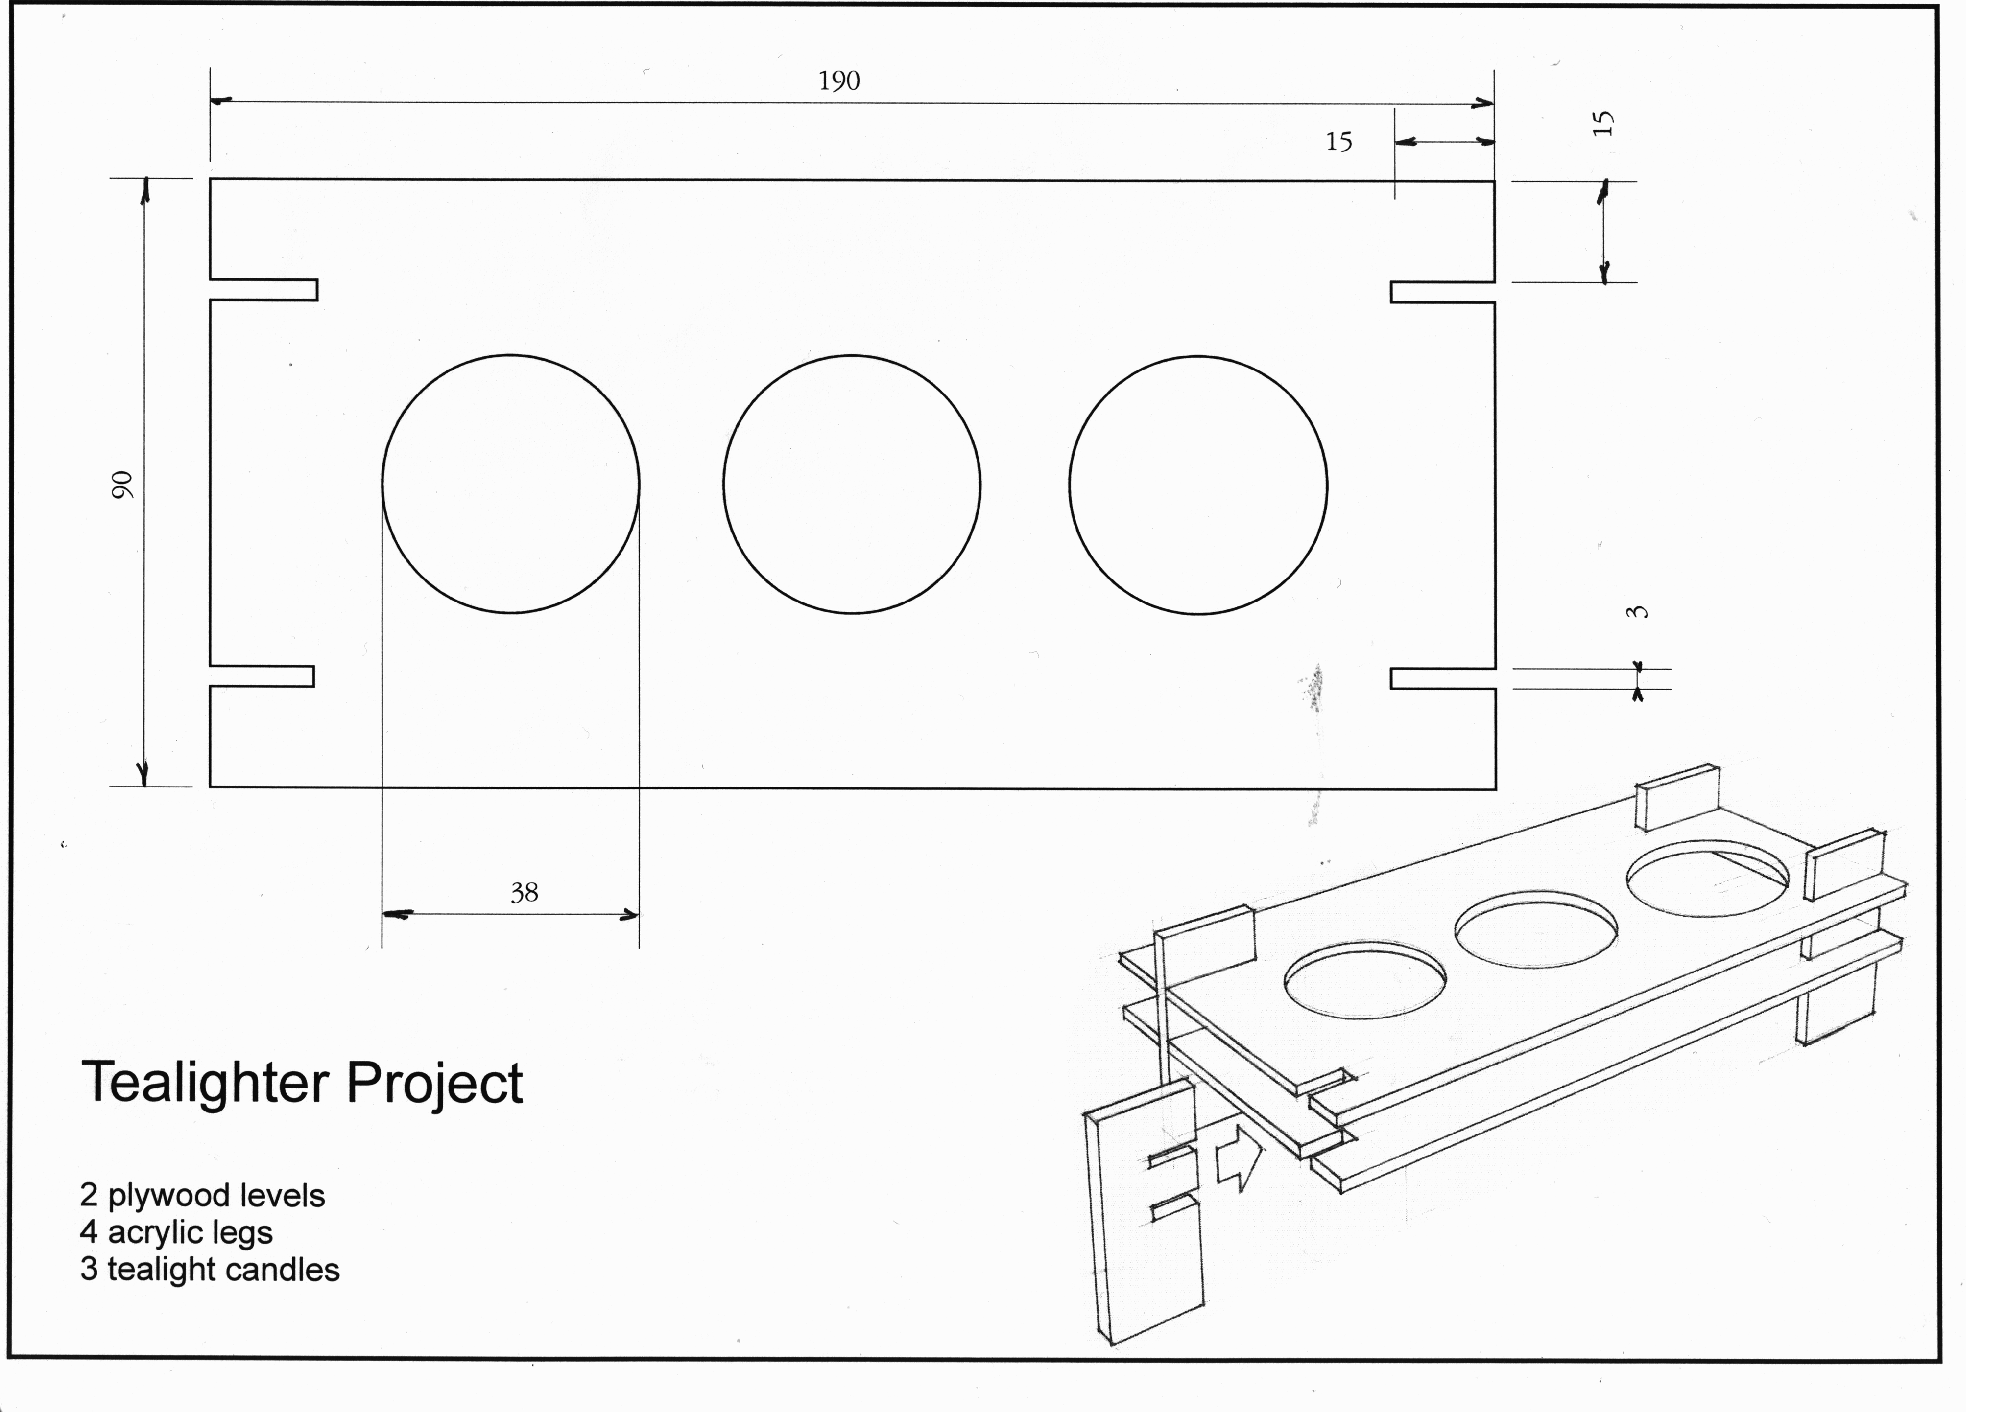

**Design Concepts**

Draw some freehand concepts using fine-liner only. Show top views and side views and try a 3D view. Label the parts. Explore a range of ideas. Example:

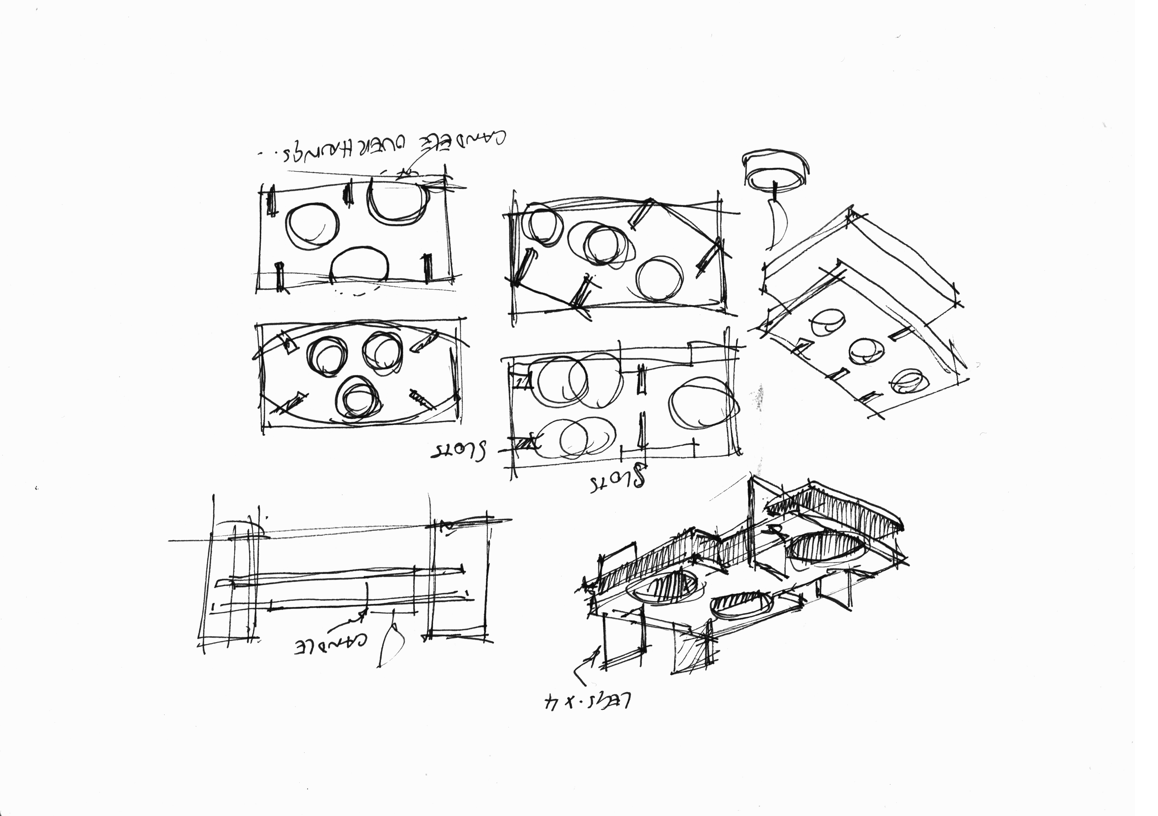

Here are some tips to remember when doing concept sketching:

* Have something that inspires you. Draw quickly. You will have more ideas if you are in a ‘drawing quickly’ frame of mind.
* Don’t be concerned about mistakes (in fact all the lines are probably ‘wrong’ so you just have to get over it and keep drawing)
* Use fineliner only. This way you can’t rub out mistakes.
* Draw lightly to begin with. These are called construction lines and will give you some idea of shapes.
* Go over the construction lines that define the shape you want. Making them darker will take your eye away from the other construction lines.
* Do some quick shading with quick diagonal lines called hatching. Make sure they are fast and light.
* Include some annotation to explain your ideas.
* If your shapes become difficult to ‘read’ then some contour lines (as above) will help define the shape you are drawing.

Fill this page with quick sketches of your ideas.

**Evaluation**

Answer the following questions.

1. What did you learn about working with plywood?
2. What changes did you make to your design during the making process?
3. Why did you make these changes?
4. If you were to make another tealighter, how would it be different to the one you have made?